**NAME:- ANIKET MISHRA**

**BRANCH:- CSIT**

**REDG. NO. :- 20010259**

**ROLL NO. :- CIT20032**

DATA STRUCTURE (LAB 01)

Experiment No. 1

1. Design a menu driven program in C to implement different operations on array. **ALGORITHM:-**

*1.Insertion of an Element: -*

*Step 1: Enter the position where we want to insert an element in an array.*

*Step 2: Input the number which you want to insert.*

*Step 3: Right shift all the elements from the given position till end of an array.*

*arr[i+1]=arr[i];*

*Step 4:Insert element at that position.*

*Step 5:Print all the element of the new array.*

2.Deletion of an Element:-

Step 1: Enter position where you want to delete an element.

Step 2: Left shift all the elements from end of an array till that position.

arr[i]=arr[i+1];

Step 3: Print all the elements of reduced array

3.Search an Element:-

Step 1: Enter the element which you want to search.

Step 2:Using for loop check whether that element is present or not in array.

arr[i]=Element(Present in array);

Step 3: If the element is present print that element is found else print that it is not found.

4. Traverse an array:-

Step 1: Access each element stored in an array by printing all the elements in an array using for loop. Step 2:Print the array

SOURCE CODE:

#include <stdio.h>

int main()

{

int ch;

int b, flag, new1;

int a[100], i, n, k;

{

printf("Enter size of the array : ");

scanf("%d", &n);

printf("Enter elements in array : ");

for (i = 0; i < n; i++)

{

scanf("%d", &a[i]);

}

}

printf("\n\n\nEnter 1 to search an element in array:\t");

printf("\nEnter 2 to traverse the array:\t");

printf("\nEnter 3 to insert an element in a particular position in arr ay:\t");

printf("\nEnter 4 to delete an element in array:\t");

printf("\n enter the choice \n");

scanf("%d", &b);

switch (b)

{

case 1:

{

printf("Enter the key : ");

scanf("%d", &k);

flag = 0;

for (i = 0; i < n; i++)

{

if (a[i] == k)

{

flag = 1;

printf("ELement Found\n");

printf("Element position:%d", i + 1);

}

}

if (flag == 0)

{

printf("Not Found");

}

}

break;

case 2:

{

printf("The array elements are:\n");

for (i = 0; i < n; i++)

{

printf("a[%d] = %d \n", i, a[i]);

}

}

break;

case 3:

{

for (i = 0; i < n; i++)

printf("%d ", a[i]);

printf("\n");

printf("Element to be inserted");

scanf("%d", &new1);

printf("Position to be inserted : ");

scanf("%d", &k);

n++;

for (i = n - 1; i >= k; i--)

a[i] = a[i - 1];

a[k - 1] = new1;

for (i = 0; i < n; i++)

printf("%d ", a[i]);

printf("\n");

}

break;

case 4:

{

printf("Enter the location where you wish to delete element\n"); scanf("%d", &b);

if (b >= n + 1)

printf("Deletion not possible.\n"); else

{

for (i = b - 1; i < n - 1; i++) a[i] = a[i + 1];

printf("Resultant array is\n"); for (i = 0; i < n - 1; i++) printf("%d\n", a[i]);

}

}

break;

default:

printf("INVALID CHOICE\n");

return 0;

}

}

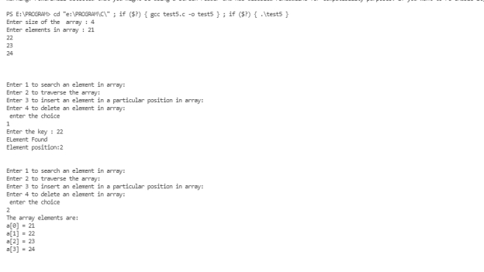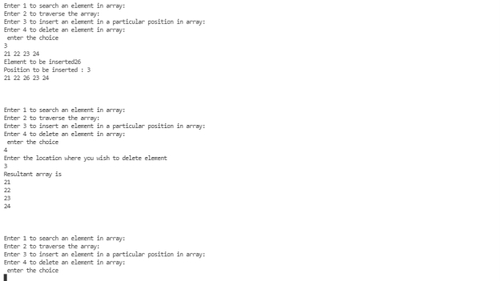

out